# “Machine Learning for Bakery Industry”

Basudev Rijal

Western Governors University

Student ID: #001365006

Table of Contents

“Machine Learning for Bakery Industry” 1

1. Project Overview 3

Organizational Need 3

Project Context and Background 3

Review of Background Works 4

Relation to Project Development 6

Summary of Machine Learning Solution 7

Benefits of Machine Learning Solution 7

2. Machine Learning Project Design 8

Scope of Project 8

Goals, Objectives, and Deliverables 8

Standard Methodology 9

Timeline and Milestones 9

Resources and Costs 9

Criteria for Successful Execution of Project 10

3. Machine Learning Solution Design 10

Hypothesis 10

Analytical Methods 10

Justification of Algorithm Selection 11

Tools and Environment of Solution 11

Measuring Performance 11

4. Description of Dataset 12

Source of Data 12

Data Collection Method 12

Advantages and Limitations 12

Quality and Completeness of Data 12

Precautions for Sensitive Data 13

References 14

# Project Overview

## **Organizational Need**

Advances in artificial intelligence (AI), machine intelligence, and a sharper focus on the internet of things (IoT) are transforming every traditional industry to automation. Especially the food industry, which worked conventional way, is now rapidly transforming to automation with the help of automated machinery. Whether their output was bread, rolls, snakes, or sweet, companies have relied on the creativity and skills of bakers and other workers to produce a quality product and to meet the client’s requirement. The conventional method was time-consuming, cause wastage, and give a low productivity rate. Therefore, food processing companies came toward automation which speeds up business by high productivity, reduce wastage, minimize human resource sources maintain product quality. But most food processing companies, especially the bakery industry, haves a conventional way of product counting. There is always a need for humans to manually count the number of produced bread and update inventory. This traditional task lowers the prediction speed and requires human resources that are slow as compared to machines and can’t work 24/7. There is a need to place a machine learning-based bread counting solution that will automatically count the number of generated pieces of bread which will boost the production speed and the industry will be able to run 24/7.

## **Project Context and Background**

The baking process is a simultaneous heat transfer process with many physical changes which injurious to human health. Baking industries have been interested in automation and convert all traditional tasks to automation. Nowadays, several parts are automated in baker industries but still, some manual tasks require more manual labors and reduce the production speed of machines.

Computer vision-based counting systems have been applied in many real-life applications. In bakery industries, a computer vision-based bread counting system will be the best alternative to a conventional bread counting system.

## **Review of Background Works**

A vision-based object counting system is one of the most important applications of surveillance systems and active research in image acquisition, computer vision, and image processing areas **[1]**. Electrodeposition industry use machine vision system for counting small metal parts which are electroplated by precious metal such as gold and platinum **[3]**. In this industry, products such as studs, clips, and buckles are electroplated by precious metals so here vision-based system overcomes the problem of wastage and loss of these important and expensive metals in the industry.

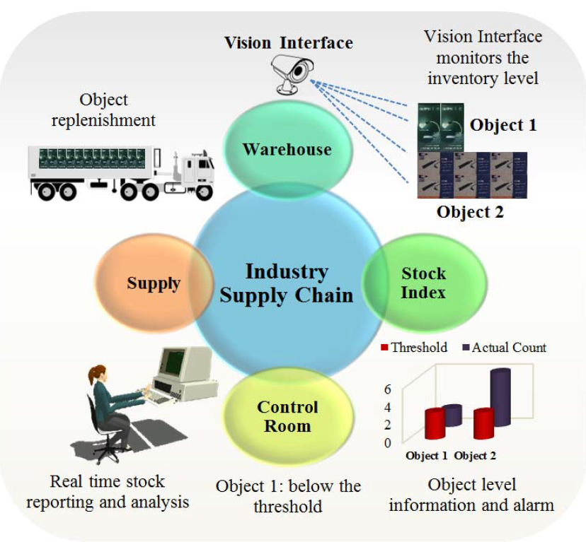

Figure 1: Inventory control

**[4][5]** proposed a vision-based vehicle detection and counting system to made an intelligent transportation system. A computer vision-based virtual detection zone is created for counting vehicles and this work benefited intelligent traffic management. Most industries use the vision-based system for counting their products and effective maintenance of inventory so that to minimize the production cost of the supply chain network **[6]**. Vision-based people counting system has a wide range of applications especially in office security and marketing research **[2]**. This makes efficient allocation of resources in buildings to handle emergencies.

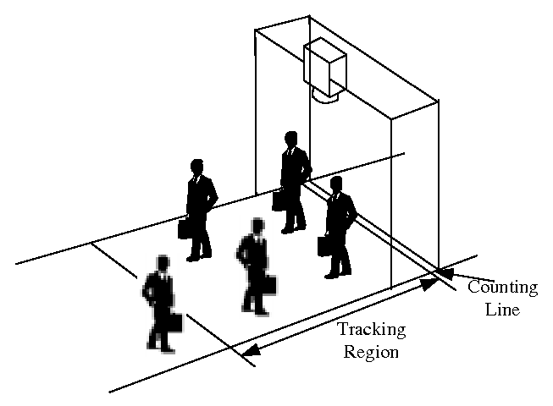

Figure 2: Vision-based people counting system

## **Relation to Project Development**

All above-mentioned counting applications are vision-based which highly relate to our proposed solution. These applications give insight into the implementation and working of the system in real-life problems. The general structure of the proposed solution is shown below which clearly shows that the proposed solution consists camera over a bread conveyor and a connection with the computer.

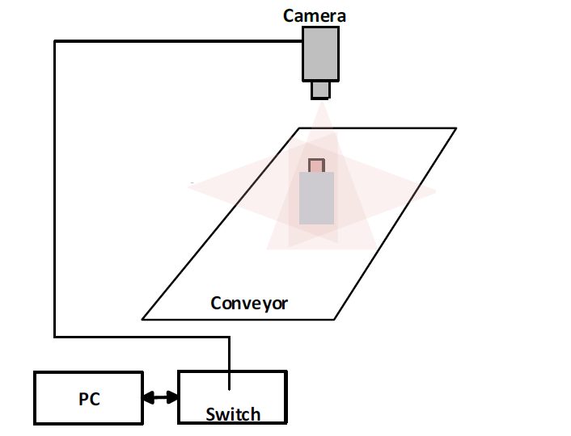

Figure 3: General structure of the proposed solution

## **Summary of Machine Learning Solution**

The vision-based bread counting system is a full machine learning solution that uses machine learning algorithms for image processing, object detection, and object counting processes. As all the bread move over the conveyor belt for baking and packing, therefore a vision-based object counting system will automatically count the bread moving on the conveyor.

## **Benefits of Machine Learning Solution**

Implementation of a vision-based bread counting system will minimize human resources, productivity time and maximize the count accuracy and excellent inventory management system where the manager will be able to check the productivity rate of the specific period.

# Machine Learning Project Design

## **Scope of Project**

As this project is based on machine learning algorithms therefore it will only work and count on the base of its algorithms training. If image processing algorithms will accurately be trained on the bread dataset, then this system will perform efficiently for just bread counting and will ignore other objects. Machine learning algorithms will fail if they are trained on lighted images but there is low light in the actual scenario. A camera placed on the conveyer should enough clean to record clear video. This project will work efficiently if its algorithm training and system placement is done efficiently.

## **Goals, Objectives, and Deliverables**

This project has its clear goals, objectives, and deliverables as it is the solution to the real-life problem in the food industry. As the proposed solution is an automated alternative to the manual bread counting problem which clearly shows that its installation goal is to automatically count several pieces of bread. Its objective is to minimize human resources and production, time boost up industry productivity with a fast and efficient product count. Finally, the number of produced bread will be the outcome of this project.

## **Standard Methodology**

The incremental methodology will be the best approach for the implementation of this project because it is a research-based solution that depends on the accuracy of its algorithms. First of all, implement its hardware on the conveyor belt then train image processing and counting algorithms and check their counting accuracy in a real-life scenario. In case, one algorithm doesn’t work well in real life scenario select another state-of-the-art model and try again. Industry can buy a pre-trained model from any tech industry to save training time.

## **Timeline and Milestones**

|  |  |
| --- | --- |
| **Milestone** | **timeline** |
| Hardware implementation | 7 days |
| Machine learning model training | 30 days |
| Validate trained model | 3 days |
| **Total Days** | **40 days** |

## **Resources and Costs**

|  |  |
| --- | --- |
| **Resources** | **Estimated Cost** |
| Camera | 150$ |
| Personal Computer | 600$ |
| Camera Stand | 50$ |
| Pre-trained algorithms | 1000$ |
| **Total** | **1800$** |

## **Criteria for Successful Execution of Project**

The output of this project is quantitative therefore its success can be easily checked after its complete installation. Run both counting methods for the particular period, manual human counting and vision-based automated counting, and check the accuracy of this newly implemented system. If several counts by a vision-based system are equal to several counts by a human then we can say that implemented system is performing best.

# Machine Learning Solution Design

## **Hypothesis**

Literature consists of many applications and benefits of object counting in different fields of life and shows different methods for object counting. Many applications used sensor-based as well as visual-based object counting and each has its pros and cons. For bread counting in a food processing factory, we will implement a vision-based bread counting system to automate counting functionality. This system can be easily implemented and will work accurately if we install it at top of the conveyor belt. A conveyor is a moving system that carries products and moves them from one place to other. Similarly, food processing factories also use this system to move bread and its materials.

## **Analytical Methods**

Object recognition is a core task of this project where our objective is to recognize bread objects in a digital image. This process consists of image classification, object localization, and object detection. Image classification is to predict the class of objects in an image, Object localization is to identify the location of one or more objects by drawing a boundary around their extent and Object detection is a hybrid of these two tasks to localize and classify one or more objects within an image. There are many machine learning models available for doing these tasks and all these models have their pros and cons. Especially different types of neural network models such as Artificial Neural Network (ANN), Recurrent Neural Network (RNN), Convolutional Neural Network (CNN) and You Only Look Once (YOLO) is commonly used for object classification, localization, detection, and recognition. We select YOLO for our system because it is a state-of-the-art method for real-time applications such as our scenario.

## **Justification of Algorithm Selection**

YOLO has a supervised learning algorithm which is the latest with state-of-the-art results in image processing applications. It can handle a large dataset during its training and can be applied in real-time applications. Speed and precise detection of small objects are the main advantages of it. But this model indicates a trade-off between speed and detection accuracy.

## **Tools and Environment of Solution**

There are four different versions of the YOLO framework family and each one has its pros and cons. If we are using one of the YOLO frameworks then there will be a need to properly install the Anaconda distribution environment of Python. Official code of algorithm can be found at GitHub (<https://github.com/AlexeyAB/darknet>).

## **Measuring Performance**

There is a specific algorithm evaluation matrix such as intersection over union (IOU), accuracy, precision, recall, and f1-score.

# Description of Dataset

## **Source of Data**

The selected food dataset belongs to iFood Compaction FGVC6 at CVPR 2019 which consists of 251 different food categories. Dataset is publicly available at Kaggle (<https://www.kaggle.com/c/ifood-2019-fgvc6/overview>).

## **Data Collection Method**

In our scenario, we will access authentic and publicly available datasets from Kaggle. This dataset has been used for competition.

## **Advantages and Limitations**

This dataset contains 251 classes of different foods which is a huge benefit of this data because the organization can use this dataset for other than bread counting. On the other hand, some food classes look like same which is a challenge for the algorithm.

## **Quality and Completeness of Data**

The selected dataset is authentic and complete as it contains training, validation, and testing data separately. Training data consists of 120,216 images, validation data consists of 12,170 images, and test data consists of 28,399 images.

## **Precautions for Sensitive Data**

This data is not sensitive but contains similar images in different classes such as there are 15 different cake classes but they look similar to each other. It is very important to select the most suitable class while training the algorithm.

# References

* + - 1. Perng, Jau-Woei, et al. "The design and implementation of a vision-based people counting system in buses." *2016 International Conference on System Science and Engineering (ICSSE)*. IEEE, 2016.
      2. Raghavachari, Chakravartula, et al. "A comparative study of vision-based human detection techniques in people counting applications." *Procedia Computer Science* 58 (2015): 461-469.
      3. Further, Rocco, et al. "Machine Vision system for counting small metal parts in the electro-deposition industry." *Applied Sciences* 9.12 (2019): 2418.
      4. Seenouvong, Nilakorn, et al. "A computer vision-based vehicle detection and counting system." *2016 8th International Conference on Knowledge and Smart Technology (KST)*. IEEE, 2016.
      5. Song, Huansheng, et al. "Vision-based vehicle detection and counting system using deep learning in highway scenes." *European Transport Research Review* 11.1 (2019): 51.
      6. Verma, Nishchal K., et al. "Vision-based object counting using speeded up robust features for inventory control." *2016 International Conference on Computational Science and Computational Intelligence (CSCI)*. IEEE, 2016.
      7. Redmon, J., Divvala, S., Girshick, R., & Farhadi, A. (2016). You only look once: Unified, real-time object detection. In *Proceedings of the IEEE conference on computer vision and pattern recognition* (pp. 779-788).